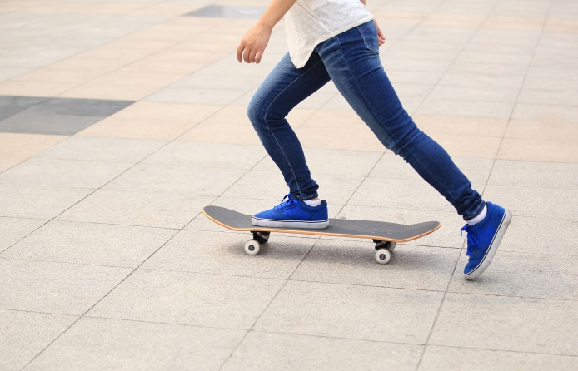Literacy support worksheet

7.1 A force is a push or a pull

Pages 120–121 and 202

Push and pull forces

1 Forces act on everything around us all the time. In the spaces provided, draw a labelled diagram to explain what forces cause objects to do. (Use different examples from those in the textbook.)

|  |  |
| --- | --- |
| Begins to move | Speeds up |
| Slows down | Changes direction |
| Changes shape | Remains still |

WORD DETECTIVE

2 Crossword

Read the clues below and place the correct answers in the crossword boxes.

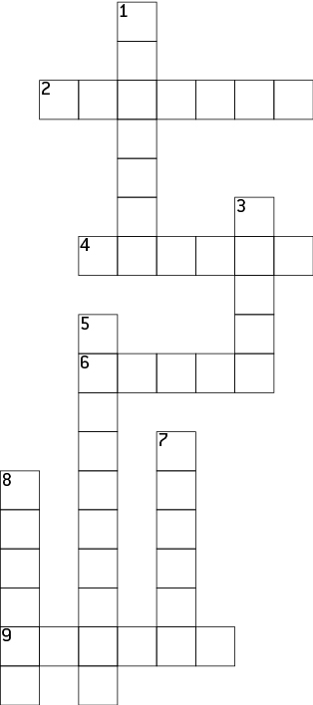

|  |  |
| --- | --- |
| **Across** | **Down** |
| 2 Is pulling you towards the centre of the Earth  4 The unit used to measure forces  6. Sir Isaac Newton first described how this fell from a tree  9 When you kick or throw a ball this is used to create a push force | 1 One way to 'see' a force is to \_\_\_\_\_\_\_\_\_\_\_ it  3 A push or pull that happens when two objects interact  5 When the stretch of the band is matched to the force pulling on it, it has been \_\_\_\_\_\_\_\_\_\_\_\_  7 In the laboratory, force is measured using a \_\_\_\_\_\_\_\_\_\_ balance  8 This type of band can measure the size of forces |

Literacy support worksheet

7.2 An unbalanced force causes change

Pages 122–123 and 203

Balanced and unbalanced forces

Force diagrams can be used to show the direction and the strength of the force.

• A short arrow shows a weak force.

• A long arrow shows a strong force.

• The same force applied in opposite directions is a balanced force.

1 Beside each diagram below, write whether the force is *balanced* or *unbalanced.*

|  |  |  |
| --- | --- | --- |
| a | WS0701_00883 |  |
| b | WS0701_00883 |  |
| c | WS0701_00883 |  |

2 Under each diagram below, draw an arrow to show the direction that the block would travel.

|  |  |  |
| --- | --- | --- |
| a | WS0702_00883 |  |
| b | WS0702_00883 |  |

The overall net force can also be worked out by looking the length and direction of the arrows. The unit of force is measured in newtons.

• Forces acting in the same direction can be added together.

• Forces acting in opposite directions can be subtracted.

3 Under each diagram below, draw an arrow to show the direction that the block would travel and calculate the amount of force (in newtons) acting on the object.

|  |  |  |
| --- | --- | --- |
| a | WS0703_00883 | Net force = \_\_\_\_\_\_\_\_\_\_\_N |
| b | WS0703_00883 | Net force = \_\_\_\_\_\_\_\_\_\_\_N |

WORD DETECTIVE

4 Mumbo-jumbo

a Use the marked letters to find the secret word (e.g. olusntoi = solution).

b Unscramble each of the clue words below to find the message.

O

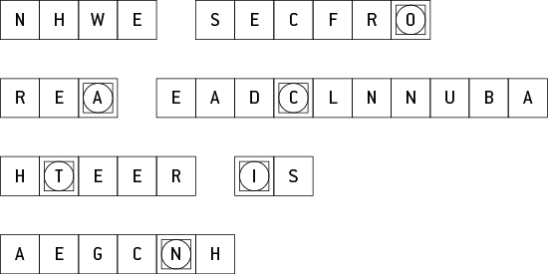

Secret word: \_\_\_\_\_\_\_\_\_\_\_\_\_\_\_\_\_\_\_\_\_\_\_\_\_\_\_\_\_\_\_\_\_\_\_\_\_\_\_\_\_\_\_\_\_\_\_\_\_\_\_\_\_\_\_\_\_\_\_\_\_\_\_\_\_\_\_\_\_\_\_\_\_\_

Message: \_\_\_\_\_\_\_\_\_\_\_\_\_\_\_\_\_\_\_\_\_\_\_\_\_\_\_\_\_\_\_\_\_\_\_\_\_\_\_\_\_\_\_\_\_\_\_\_\_\_\_\_\_\_\_\_\_\_\_\_\_\_\_\_\_\_\_\_\_\_\_\_\_\_\_\_

Literacy support worksheet

7.3 Forces can be contact or non-contact

Pages 124–125 and 203

Magnetic force

1 Magnets are an example of a non-contact force. What does this mean?

2 On each of the diagrams below, write whether the force between the magnets is an *attraction* or a *repulsion*. Include an arrow to indicate the direction of the force.

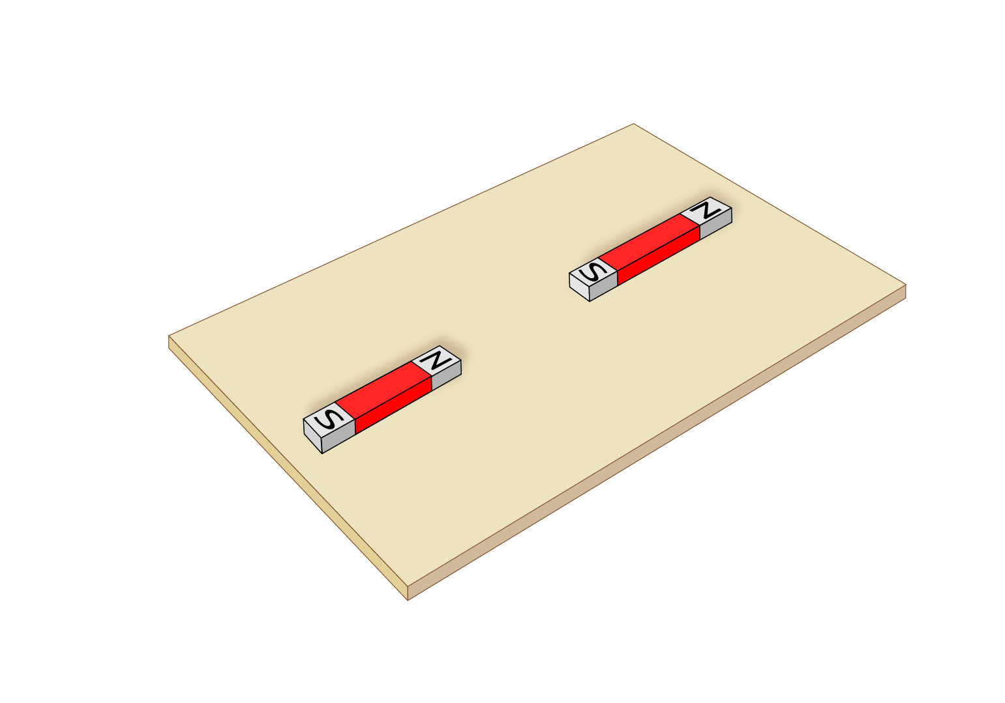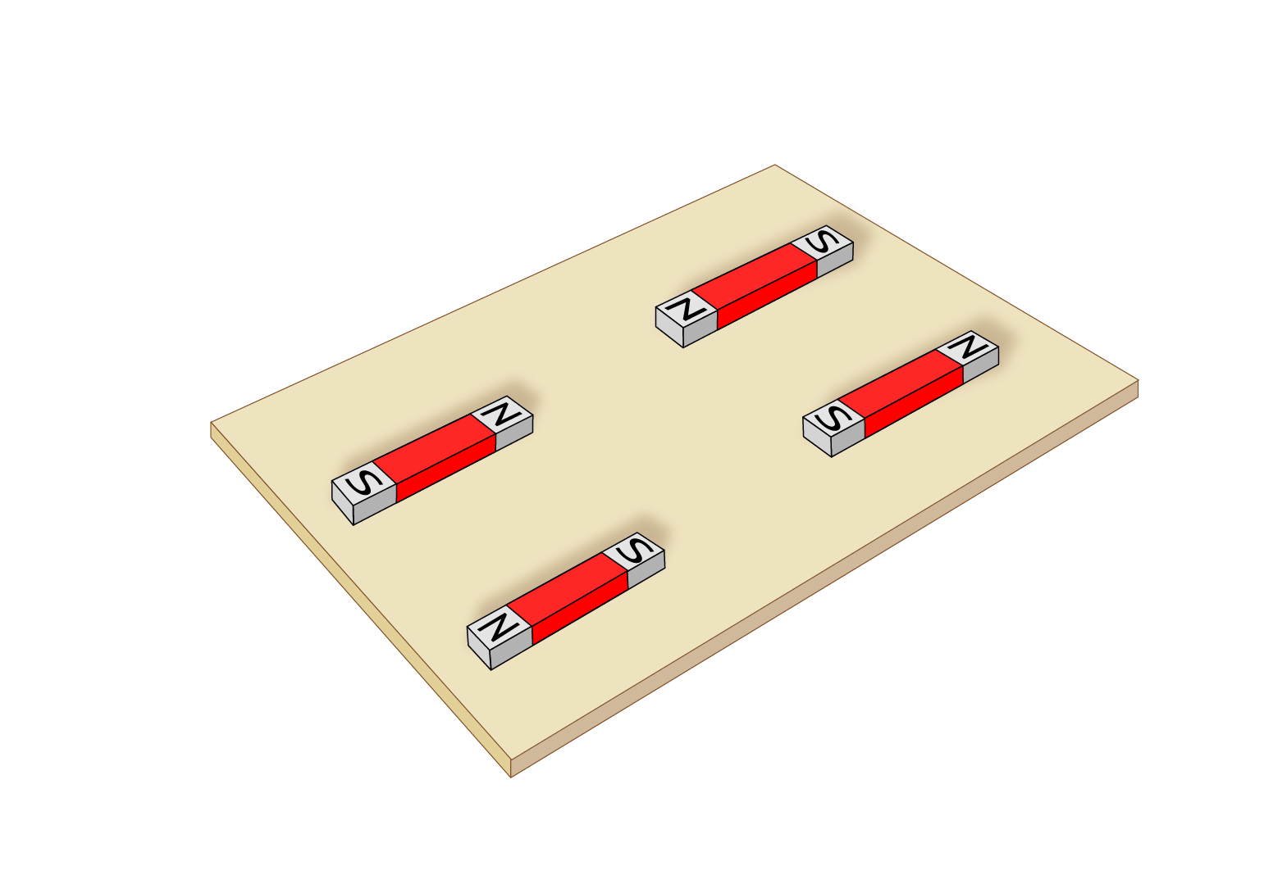

WORD DETECTIVE

3 Draw and label

Use the words below to label a simple sketch of Maglev used for trains.

magnetic levitation floating friction alloy magnets surface repel steel

|  |
| --- |
|  |

Literacy support worksheet

7.4 Magnetic fields can apply a force from a distance

Pages 126–127

Magnetic fields

1 Iron filings are scattered around a bar magnet below, to show the magnetic field.

a Why do you think iron filings were used to show the magnetic field instead of something bigger like a steel bar?

b Magnetic field lines should point away from the north pole of the magnet and towards the south pole of the magnet. Draw a map of the magnetic field lines on the second magnet.

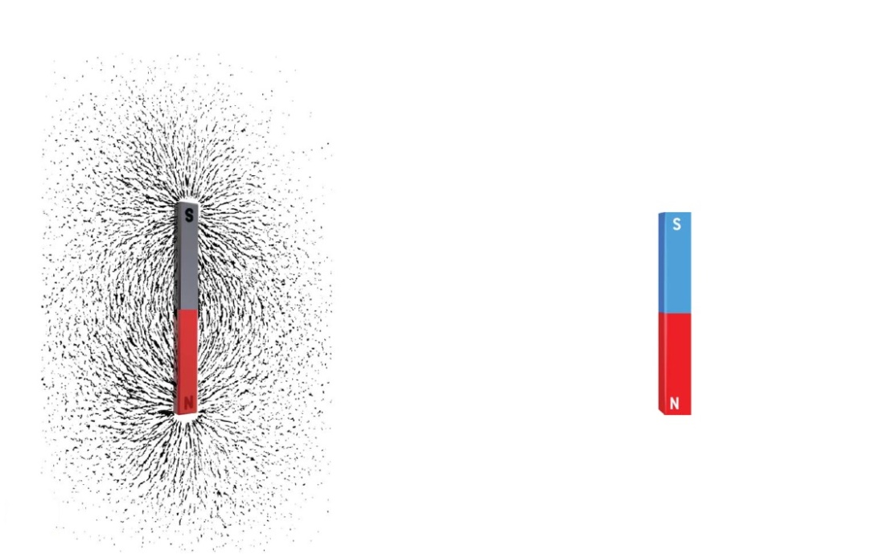

c Draw a map of the magnetic field lines on the magnet below, which is the other way around.

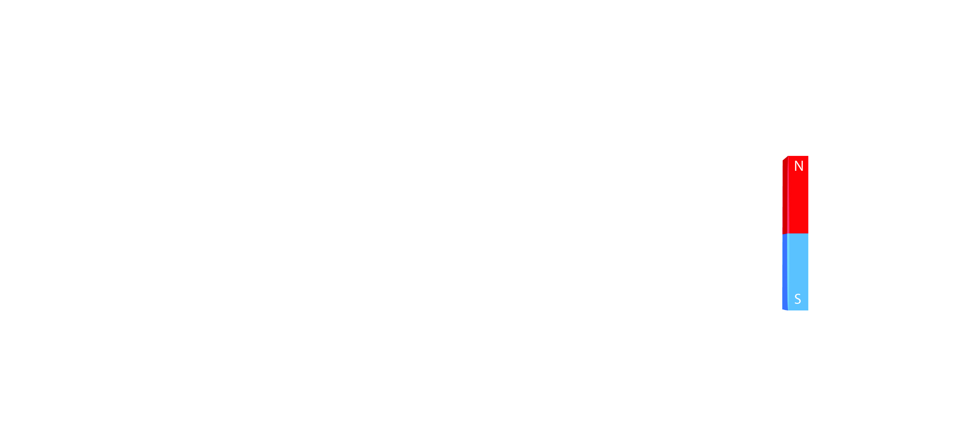

2 The Earth is like an enormous magnet with its own north and south poles.

Draw magnetic field lines on the diagram of the Earth below.

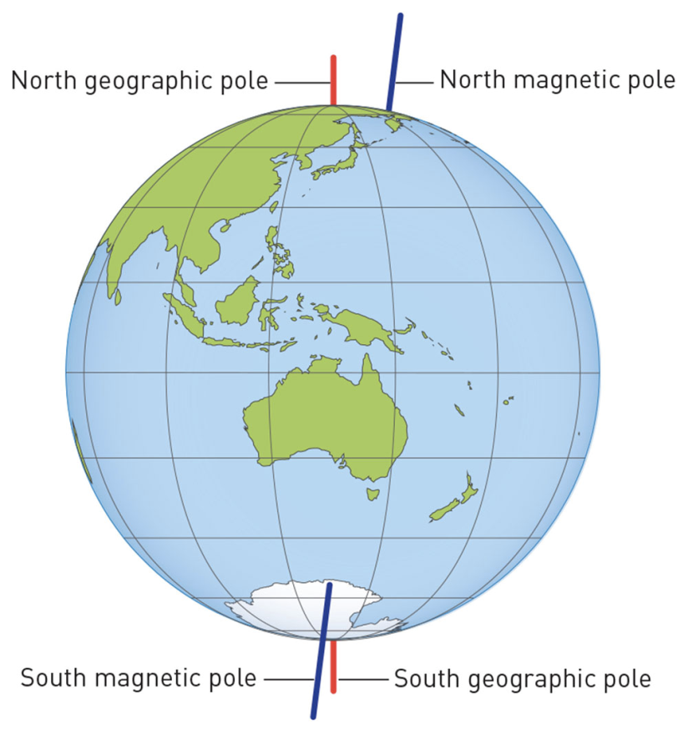

WORD DETECTIVE

3 Fill in the blanks

Fill in the gaps using magnetic field information.

compass navigate magnetosphere magnetic animals magneto-sensing

migrating poles research Earth evidence field

The \_\_\_\_\_\_\_\_\_\_\_\_is like a giant magnet with north and south\_\_\_\_\_\_\_\_\_\_\_\_. It is surrounded by a \_\_\_\_\_\_\_\_\_\_\_\_field that extends way beyond the Earth’s atmosphere called the \_\_\_\_\_\_\_\_\_\_\_\_. Many animals use the magnetic \_\_\_\_\_\_\_\_\_\_\_\_of the Earth like a \_\_\_\_\_\_\_\_\_\_\_\_to navigate their way. Scientific \_\_\_\_\_\_\_\_\_\_\_\_has found that birds use the Earth’s magnetic field when \_\_\_\_\_\_\_\_\_\_\_\_.

These days we now know that many \_\_\_\_\_\_\_\_\_\_\_\_use the Earth’s magnetic field to\_\_\_\_\_\_\_\_\_\_\_\_. Snails, fruit flies, bees, butterflies, salamanders, newts, lobsters, frogs, bats, salmon, trout, whales, sea turtles and the mole rat of East Africa can, too. There is some \_\_\_\_\_\_\_\_\_\_\_\_ to suggest that humans have \_\_\_\_\_\_\_\_\_\_\_\_abilities too.

Literacy support worksheet

7.5 Electrostatic forces are non-contact forces

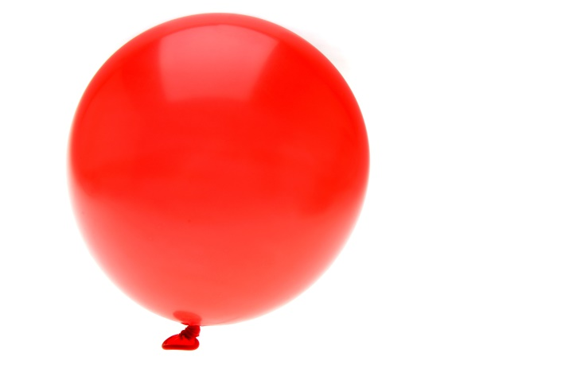Pages 128–130 and 204

Static electricity

1 With charged objects, the rules: ‘opposites attract’ and ‘like repels like’ can be used.

In each of the situations below, write whether the objects will: *attract, repel* or *do neither*.

a Two negatively charge objects: \_\_\_\_\_\_\_\_\_\_\_\_\_\_\_\_\_\_\_\_\_\_\_\_\_

b Two positively charged objects: \_\_\_\_\_\_\_\_\_\_\_\_\_\_\_\_\_\_\_\_\_\_\_\_\_

c A positively charged object and a negatively charged object: \_\_\_\_\_\_\_\_\_\_\_\_\_\_\_\_\_\_\_\_\_\_\_\_\_

d A positively charged object and a neutral object: \_\_\_\_\_\_\_\_\_\_\_\_\_\_\_\_\_\_\_\_\_\_\_\_\_

e A negatively charged object and a neutral object: \_\_\_\_\_\_\_\_\_\_\_\_\_\_\_\_\_\_\_\_\_\_\_\_\_

f Two neutral objects: \_\_\_\_\_\_\_\_\_\_\_\_\_\_\_\_\_\_\_\_\_\_\_\_\_

2 Use the words below to complete the following sentences about electrostatic charges.

towards rubbed positive or negative electrostatic

negative charged static lost

attracted equal or balanced negative charges or electrons

When objects are \_\_\_\_\_\_\_\_\_\_\_\_\_\_ they become \_\_\_\_\_\_\_\_\_\_\_\_\_\_ because they have \_\_\_\_\_\_\_\_\_\_\_\_\_\_\_\_ or gained \_\_\_\_\_\_\_\_\_\_\_\_\_\_\_\_\_\_\_\_\_\_\_\_\_.

If they are placed near neutral objects (which have \_\_\_\_\_\_\_\_\_\_\_\_\_\_\_\_\_\_\_\_\_\_\_\_\_ positive and \_\_\_\_\_\_\_\_\_\_\_\_\_\_\_\_\_\_\_\_\_\_\_\_\_ charges) they will be \_\_\_\_\_\_\_\_\_\_\_\_\_\_\_\_\_\_\_\_\_\_\_\_\_ to the \_\_\_\_\_\_\_\_\_\_\_\_\_\_\_\_\_\_\_\_\_\_\_\_\_ charges and will move \_\_\_\_\_\_\_\_\_\_\_\_\_\_\_\_\_\_\_\_\_\_\_\_\_ that object. This attraction or \_\_\_\_\_\_\_\_\_\_\_\_\_\_\_\_\_\_\_\_\_\_\_\_ force due to charges is called \_\_\_\_\_\_\_\_\_\_\_\_\_\_\_\_\_\_\_\_\_\_\_\_\_ electricity.

3 Using the space below, draw a sketch of yourself touching a Van de Graaff generator. Add labels to the diagram, including:

• the negatively charged electrons travelling from you to the dome

• the negative charges on the dome attracting neutral objects like paper

• each positively charged hair repelling the next one, making it stand on end.

|  |
| --- |
|  |

WORD DETECTIVE

4 Word search

Find as many words as possible in the puzzle below.

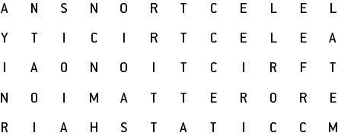

Literacy support worksheet

7.6 Friction slows down moving objects

Pages 130–131 and 205

Friction

1 Use the words below to fill in the gaps.

surface movement more or less smoother or rougher contact (use twice)

rubs greater heat more/less

Friction is a \_\_\_\_\_\_\_\_\_\_\_\_\_\_\_\_\_\_\_\_\_\_ force. It works when the surface of one object \_\_\_\_\_\_\_\_\_\_\_\_\_\_\_\_\_\_\_\_\_\_ against the \_\_\_\_\_\_\_\_\_\_\_\_\_\_\_\_\_\_\_\_\_\_\_ of another object. The greater the area of \_\_\_\_\_\_\_\_\_\_\_\_\_\_\_\_\_\_\_\_\_\_ between surfaces, the greater the friction. Friction acts in the opposite direction to \_\_\_\_\_\_\_\_\_\_\_\_\_\_\_\_\_\_\_\_\_\_. The \_\_\_\_\_\_\_\_\_\_\_\_\_\_\_\_\_\_\_\_\_\_ the surface, the more/less friction there is and the \_\_\_\_\_\_\_\_\_\_\_\_\_\_\_\_\_\_\_ an object can move. Friction can generate \_\_\_\_\_\_\_\_\_\_\_\_\_\_\_\_\_\_\_\_\_ when objects are moving: the greater the friction, the \_\_\_\_\_\_\_\_\_\_\_\_\_\_\_\_\_\_\_\_\_\_\_ the heat made.

2 Give an example of a situation where *reducing*friction is an advantage.

3 Give an example of a situation where *increasing* friction is an advantage.

4 Study the diagrams of different surfaces. Rank the surfaces from 1 (least frictional force) to 4 (most frictional force).

|  |  |  |  |
| --- | --- | --- | --- |
| Carpet | Rocks | Ice | Wet grass |
| WS0709_00883-rf | WS0710_00883-rf | WS0711_00883-rf | WS0712_00883-r |

5 Scientists are still unable to explain how the pyramids in Egypt were built because of the weight of the heavy boulders. Explain one method you could use to reduce friction and *push* a heavy boulder across the ground.

WORD DETECTIVE

6 Match-a-word

Draw a line from the words to their meanings.

Friction Makes the surface smooth and rounded, reduces air resistance

Air resistance When the surface of two objects connect.

Lubrication Friction between a moving object and the air

Grip Another word for tug or air resistance

Drag Tiny balls that reduce friction

Ball bearings The grip of an object on a surface

Streamlining Decreasing friction with a substance between surfaces

Literacy support worksheet

7.7 Simple machines decrease the amount of effort needed to do work

Pages 132–133 and 206–207

Simple machines

The Ancient Egyptians developed simple machines to help them with building the pyramids.

1 The picture below shows the Ancient Egyptians using different types of levers. Write which materials are being used as levers and how.

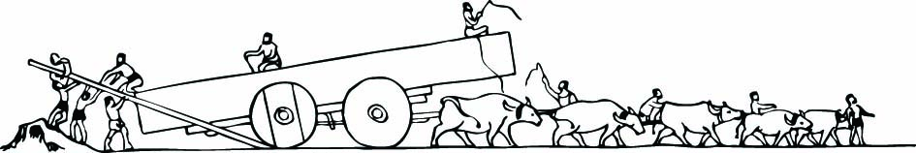

2 Below are diagrams of the three classes of lever. For each diagram:

• identify the class of the lever

• label the fulcrum, load and the direction of the effort

• draw an example (different from those in the textbook) of this type of lever.

|  |  |  |
| --- | --- | --- |
| a | WS0717_00883-r |  |

|  |  |  |
| --- | --- | --- |
| b | WS0718_00883-r |  |

|  |  |  |
| --- | --- | --- |
| c | WS0719_00883-r |  |

3 A lever can give you a mechanical advantage. The size of the advantage can be calculated by dividing the size of the load by the size of the effort:

Example: A wheelbarrow has a 3 N load and needs 1 N effort to lift it.

What is the mechanical advantage of the wheelbarrow?

$$Mechanical advantage = \frac{size of the load}{size of the effort}$$

$$= \frac{3}{1}$$

= 3

a A boulder has a 10 N load and needs 5 N of effort to move it using a lever. What is the mechanical advantage of the lever?

Mechanical advantage =

b A nail had a 9 N load of resistance and needs 3 N of effort using a hammer to remove it. What is the mechanical advantage of the hammer?

Mechanical advantage =

WORD DETECTIVE

4 Word search

Find the words listed, in the puzzle below.

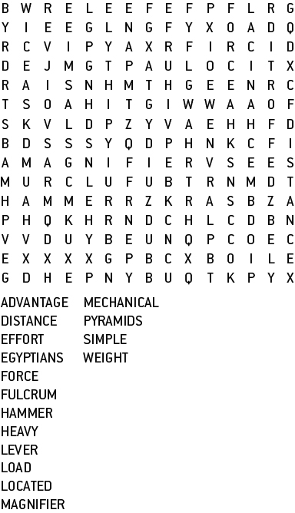 

Literacy support worksheet

7.8 A pulley changes the size or direction of force

Pages 134–135 and 208

Pulleys

The pictures show pulley systems helping a person lift bigger loads.

1 Fill in the missing information in each picture. Part (a) has been done for you as an example.

D = how far the mass would be raised

F = the force required

|  |  |  |  |
| --- | --- | --- | --- |
| a | L:\1. Publishing and Editorial\1. Product\Oxford Science\Oxford Science 7\3. Extras\7. Student worksheets\Artwork\4. Final jpgs\from Perms\Edited artwork from Julia\Chapter 7\JPEGs\WS0742_00883-r.jpg | b | L:\1. Publishing and Editorial\1. Product\Oxford Science\Oxford Science 7\3. Extras\7. Student worksheets\Artwork\4. Final jpgs\from Perms\Edited artwork from Julia\Chapter 7\JPEGs\WS0723_00883-r.jpg |
| c | L:\1. Publishing and Editorial\1. Product\Oxford Science\Oxford Science 7\3. Extras\7. Student worksheets\Artwork\4. Final jpgs\from Perms\Edited artwork from Julia\Chapter 7\JPEGs\WS0721_00883-r.jpg | d | L:\1. Publishing and Editorial\1. Product\Oxford Science\Oxford Science 7\3. Extras\7. Student worksheets\Artwork\4. Final jpgs\from Perms\Edited artwork from Julia\Chapter 7\JPEGs\WS0724_00883-r.jpg |

L = the length of the rope

M = the mechanical advantage

WORD DETECTIVE

2 Secret message

Use words from the student book to work out the secret message below:

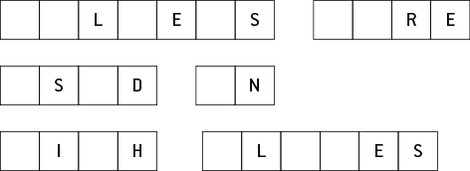

Literacy support worksheet

7.9 There are different types of machines

Pages 136–137 and 208

Types of machines

1 Look at the ramps in the two images below.

|  |  |
| --- | --- |
| WS0726_00883-rf | WS0727_00883-rr |

Which ramp do you think would take the least amount of effort to walk up? Explain your answer.

2 How do your front teeth (incisors) act as a wedge when you bite into a carrot or apple?

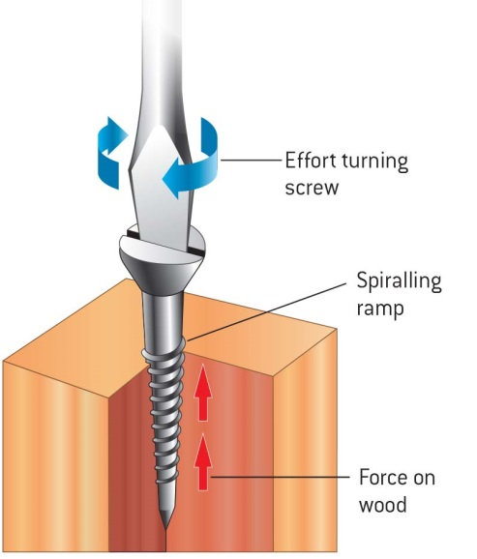

3 There is a saying ‘righty tighty, lefty loosey’. Which direction would take more effort to turn the screw, ‘clockwise’ or ‘anti-clockwise’?

4 Label the following features on the diagram:

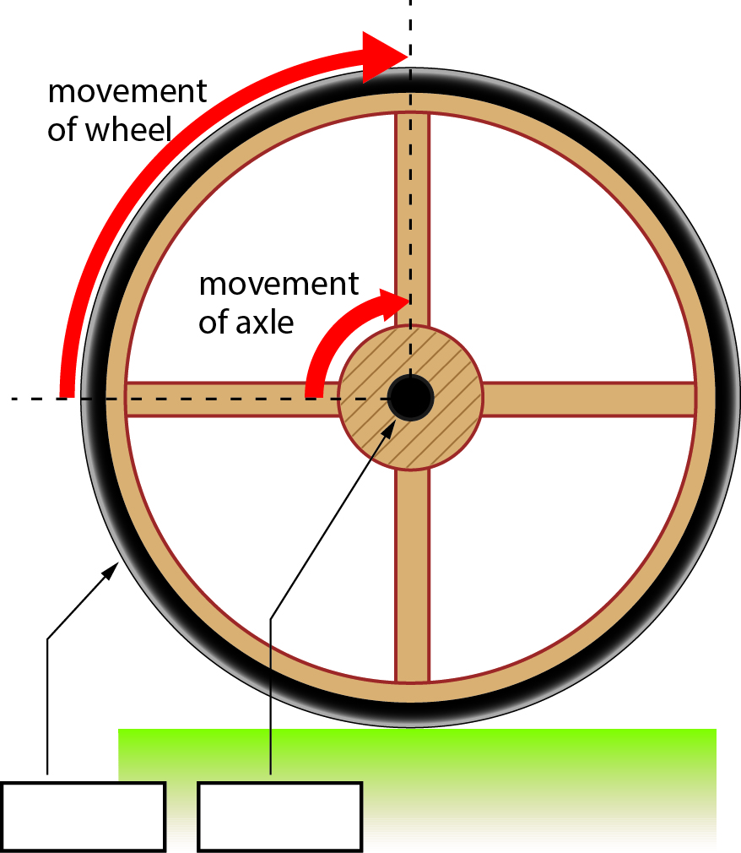

• wheel (the lever)

• axle (links the fulcrum to the wheel)

5 A wheel is a distance multiplier. On a bike, the smaller pedal in the middle would turn, causing the larger outside wheel to turn.

How does the size of the wheel increase the distance travelled?

WORD DETECTIVE

6 True or false?

Read each statement below and circle T if it is true or F if it is false.

a A screw is an inclined plane T or F

b Going up stairs takes less force off your legs than a ramp T or F

c The outside edge of a wheel moves a larger distance than its axle T or F

d The distance travelled by a pedal on a bike is greater than that of the wheel T or F

e A wedge changes the direction of a sideways force to a downwards one T or F

f A ramp is a simple machine T or F

Literacy support worksheet

7.10 Science as a human endeavour: Forces are involved in sport

Pages 138–139

Forces in the body and sport

Forces in swimming

1 What is the most efficient body position for a swimmer?

2 List the features of the full-body ‘smart suits’ that provided an advantage to the swimmers wearing it.

Forces in tennis

3 Label the parts of the tennis player’s body that provide the fulcrum, effort and load.



4 What kind of lever is a tennis racquet?

5 How does a longer tennis racquet help?

Forces in golf

6 Label the diagram below to help explain why golf balls have dimples.

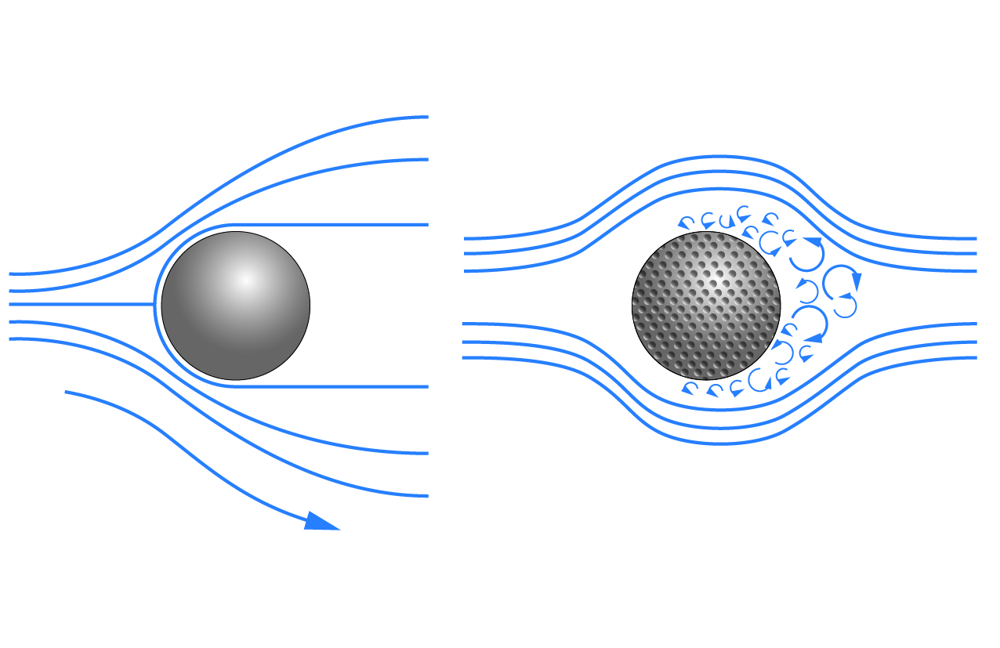

WORD DETECTIVE

**7** Crossword

Revise your knowledge of the Forces chapter by reading the clues below and placing the correct answers in the crossword boxes.

**Across**

1 The simplest form of inclined plane

4 Rod or bar that is supported by a fulcrum

5 A type of lever that turns in circles

**Down**

2 Links a lever and a wheel

3 An inclined plane that moves through another object

6 The weight of an object or person

